

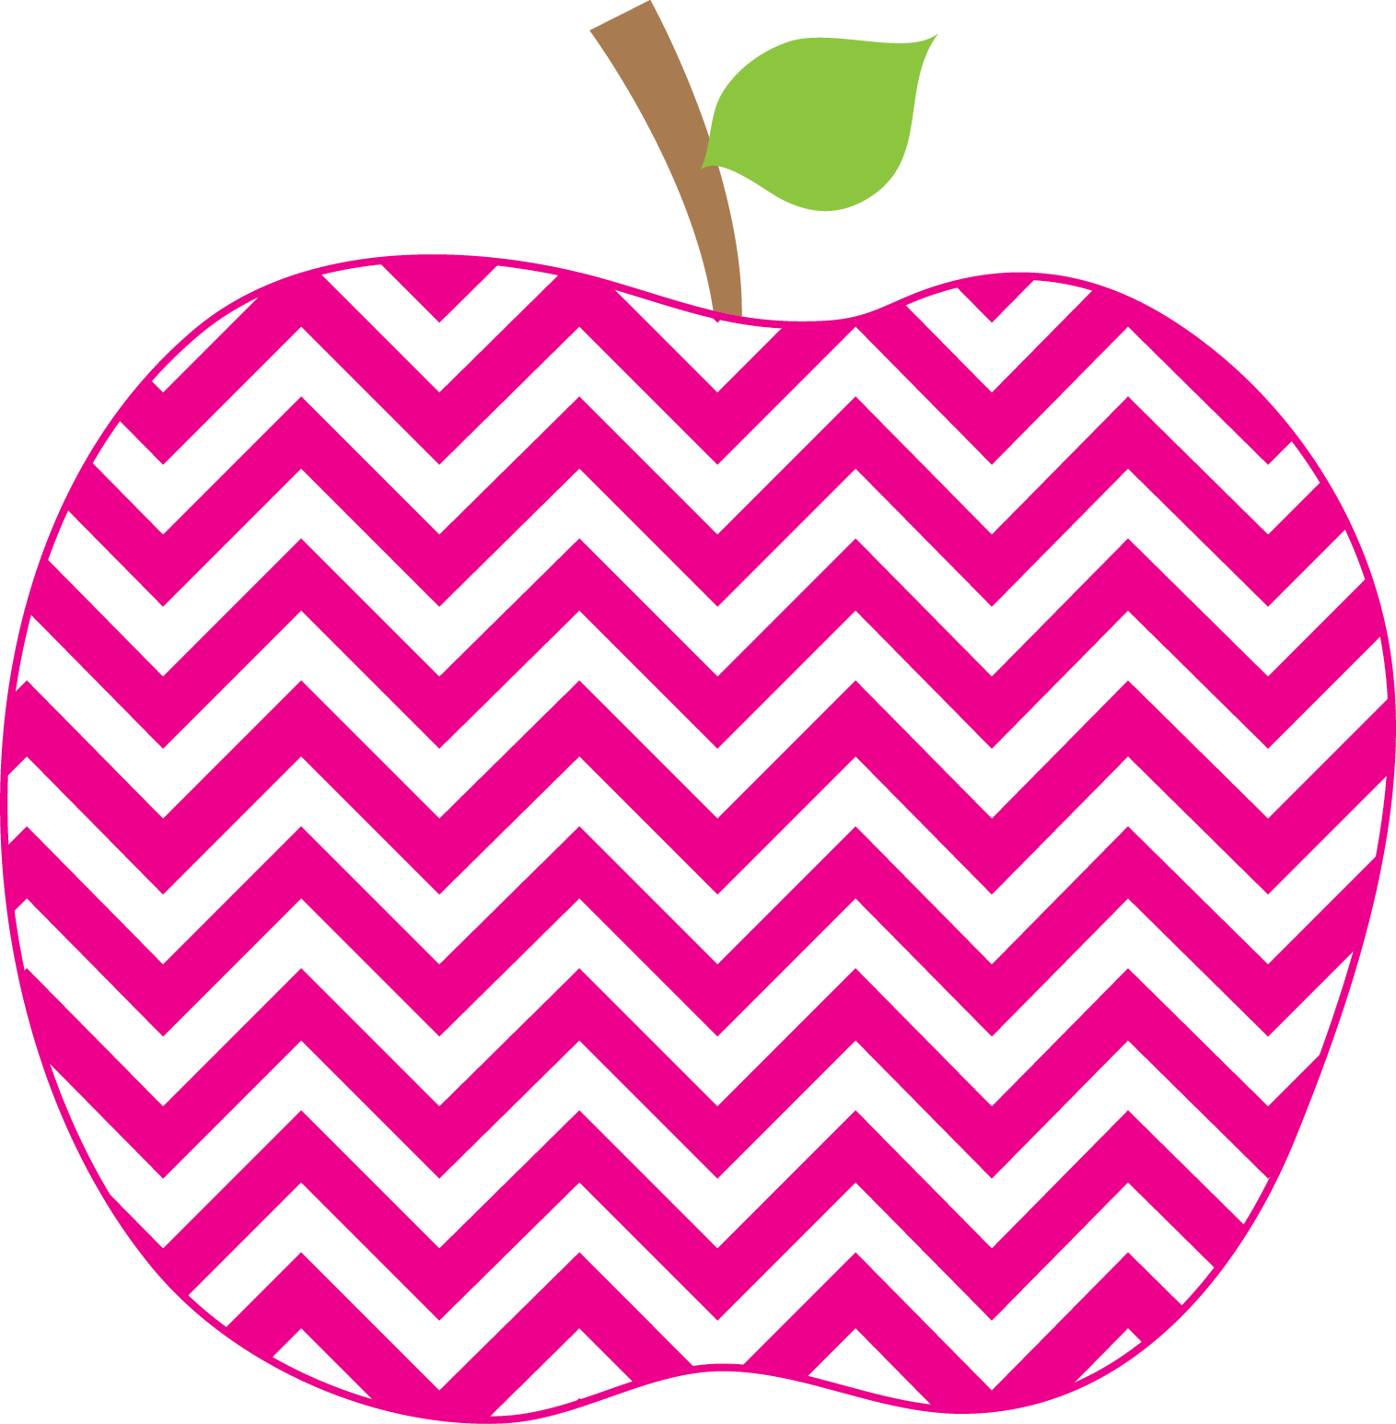



Austria’s Class News
Ms.
November 1, 2024

Phonics- This week we have been continuing to learn that when there are two letters together that are the same letter (ll, ss , and zz) they make only one sound. We have also been reviewing our digraphs and have learned the “ph” digraph and the sound these two letters make together.

Reading- We are continuing to learn about the five story elements when we are reading (character, setting, events in the beginning middle and end, problem and solution). We also began our small groups and are working on various skills in our groups.

Writing- We have continued to write about small moments and to add as much detail to our writing as possible. Additionally, we are continuing to add emotion and expressions to our writing so when others read our writing they know exactly how we feel throughout our writing. This week we have been learning to add transition words to our writing (Frist, Next, Then, and Finally).

Math- We are continuing to learn about bar graphs and pictographs. We are continuing to learn how to make tally marks when counting objects to graph. We have started to learn how to take data and make either a bar graph or a pictograph with the data.

Science- This week we are continuing to learn what Matter is and the different properties that Matter has. We have also been continuing to learn how to sort objects according to their properties. This week we built a bridge out of different objects to see what materials would best support the weight of 21 bears. We had a lot of fun building our bridge.

This Week’s Focus
Celebrations
Elijah’s Birthday November 2nd!

There is no school Tuesday November 5th
Parent Teacher conferences are scheduled for November 20th, 21st and 22nd.
Reminders
Upcoming Events

